# Updated Software Testing Plan(S3)

## Reflections

Agile testing methodology has thus far been successful in achieving the quality objectives of the project. Increases in the project’s complexity have been well tolerated by the test methodology. Manual black box testing has been sufficient. Test methodology for the final sprint will remain unchanged. Testing will continue to focus primarily on key functionality from a user perspective.

## Testing Overview

Testing will be conducted on the program in its entirety, including all previously-tested features to **monitor effect of changes.** Full testing will ensure new features and fixes have not broken existing modules. The testing methodology, strategy, and metrics are consistent with those detailed in the Sprint One testing plan.

### Scope

The new proposed features are detailed alongside previously developed features in the following revised testing scope:

#### In Scope

* User authentication
* Display database
* Search database
  + With any combination of parameters
* Top ten movies
* Operation on three different sized devices
  + PC
  + Tablet/Laptop
  + Phone
* User subscription
* Unsubscribe option
* Email user with:
  + Newsletter
  + Newsflash updates

**New features to be tested for SPRINT THREE:**

* Admin page
* Authentication system for accounts
* Admin features locked behind admin accounts
* Top 10 ratings
* System for rating movies out of 10
* Users can enter ratings
* Page for showing top 10 rated movies that updates live

#### Out of Scope

* User account recovery
* Thumbnails with theatrical posters/cover art

## Test Table

|  |  |  |  |  |  |  |  |  |
| --- | --- | --- | --- | --- | --- | --- | --- | --- |
| Test Report S3 T1 | | | | | | | | |
| Project Name: RAD Sprint Three | | | Test Type: White box | | | | | |
| Description: Movie Search Application | | | Date: 11/06/2021 | | | | | |
| Developer(s): Blake Topham, Erol Anil, Nathan Tai | | | Tester: Blake Topham | | | | | |
| Test Case # | Test Case Name | Test Steps | | Test Data | | Expected Results | Evidence | Pass? |
| 1 | Search by Name | Enter search terms | | Search term | | Matching results displayed | Figure 27 |  |
| 2 | Search by Name, Genre | Enter search terms | | Search term | | Matching results displayed | Figure 28 |  |
| 3 | Search by Name, Genre, Rating | Enter search terms | | Search term | | Matching results displayed | Figure 29 |  |
| 4 | Search by Name, Genre, Rating, Year | Enter search terms | | Search term | | Matching results displayed | Figure 30 |  |
| 5 | Top Ten Movies | Click “10 Most Searched” button | | 10 movies with highest search count | | 10 movies with highest search count displayed | Figure 31 |  |
| 6 | Runs on: Desktop PC | Run page in desktop browser | | Page elements | | Page runs | Figure 32 |  |
| 7 | Runs on:  iPad | Run page in device simulation mode | | Page elements | | Page runs | Figure 33 |  |
| 8 | Runs on: Galaxy S5 | Run page in device simulation mode | | Page elements | | Page runs | Figure 34 |  |
| 9 | User subscribes | Enter email and click subscribe | | Email address | | User subscribed, receives newsletter/newsflash | Figure 35 |  |
| 10 | User unsubscribes | Enter email and click unsubscribe | | Email address | | Email sent to Admin account for database removal | Figure 36 |  |
| 11 | Admin removes user | Run admin user unsubscribe command. | | User details(email, etc.) | | User entry set to unsubscribed | Figure 37 |  |
| 12 | Admin login | Enter admin details | | Admin login details | | Admin features enabled | Figure 38 |  |
| 13 | User adds rating | Enter rating as user | | Score | | Rating added to database | Figure 39 |  |
| 14 | Rating auto-updates on page | View any movie search results | | Score | | Rating auto-updates on page | Figure 40 |  |
| Test Completeness Criteria Achieved:  1. All test cases carried out successfully  2. All bugs fixed | | | | | Suspension Criteria Met:  1. Vital functionality broken  2. Error directly prevents further testing  3. Errors too many or too often  4. Error makes further testing redundant | | | |
| Testing Complete | | | | | Testing Suspended | | | |

### Screenshots

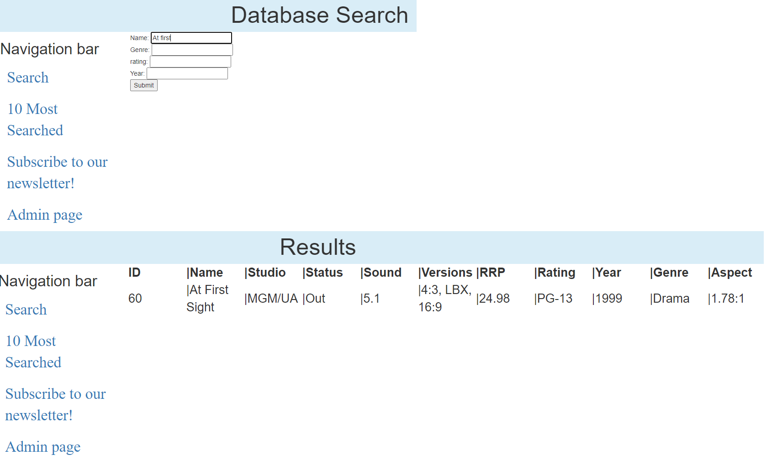

Figure 28- Search by name

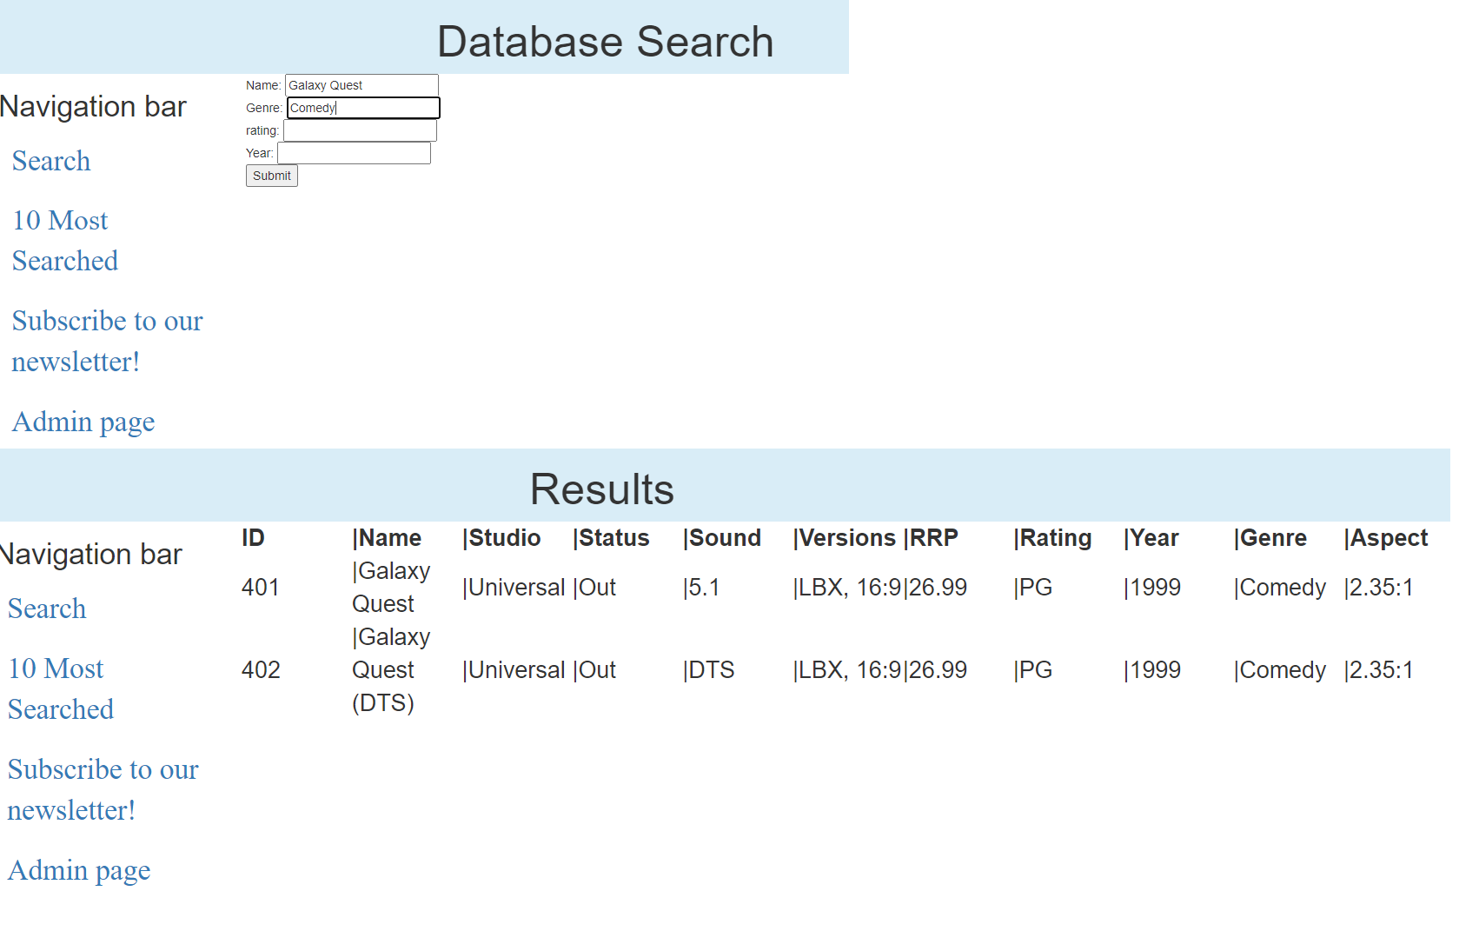

Figure 29- Name, Genre

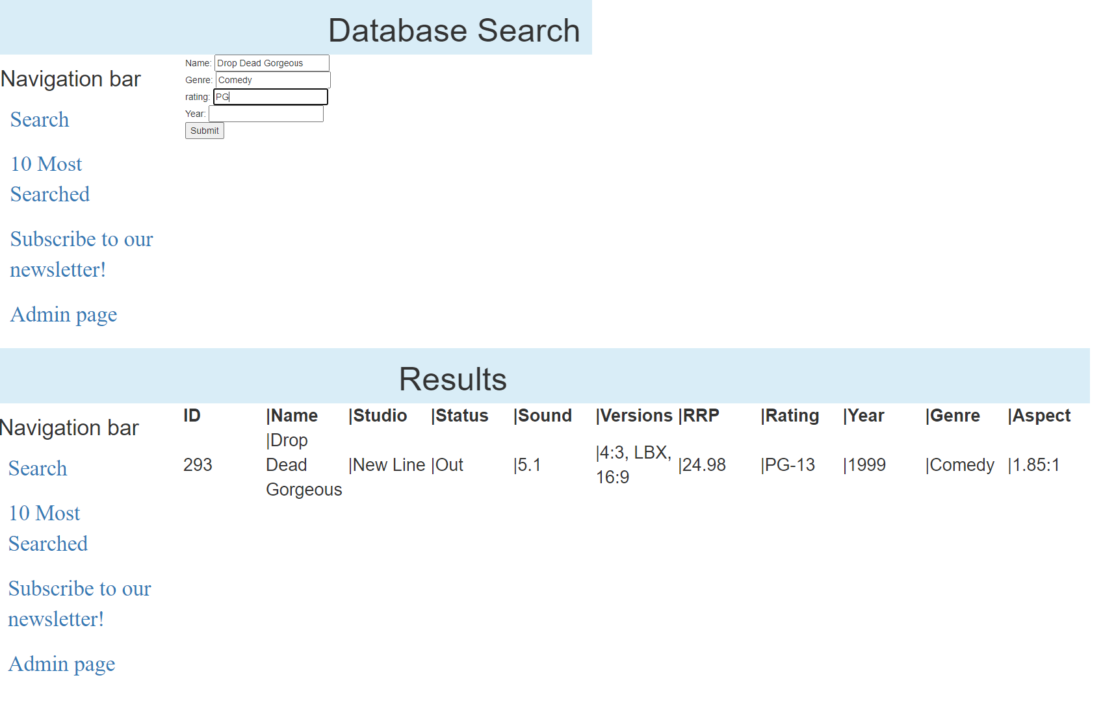

Figure 30-Name, Genre, Rating

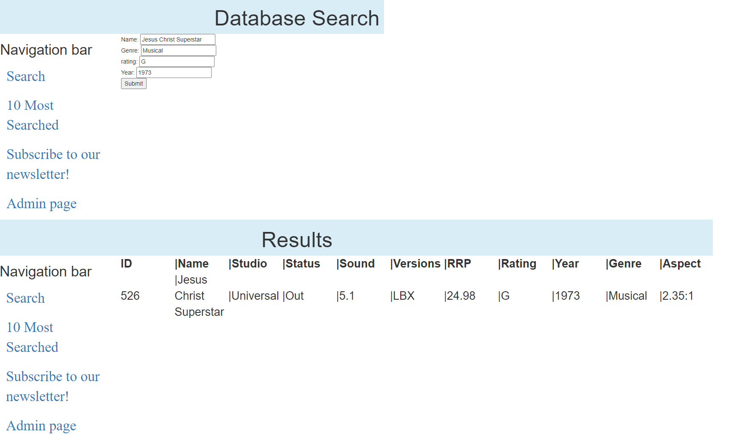

Figure 31- Name, Genre, Rating, Year

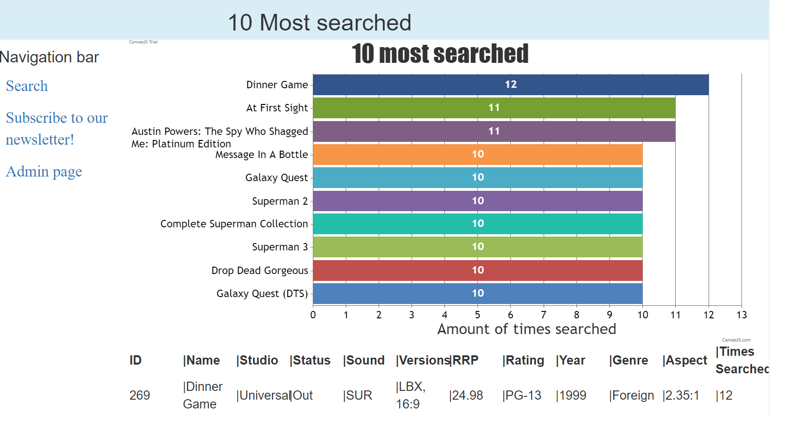

Figure 32- Top ten



Figure 33- Runs on PC

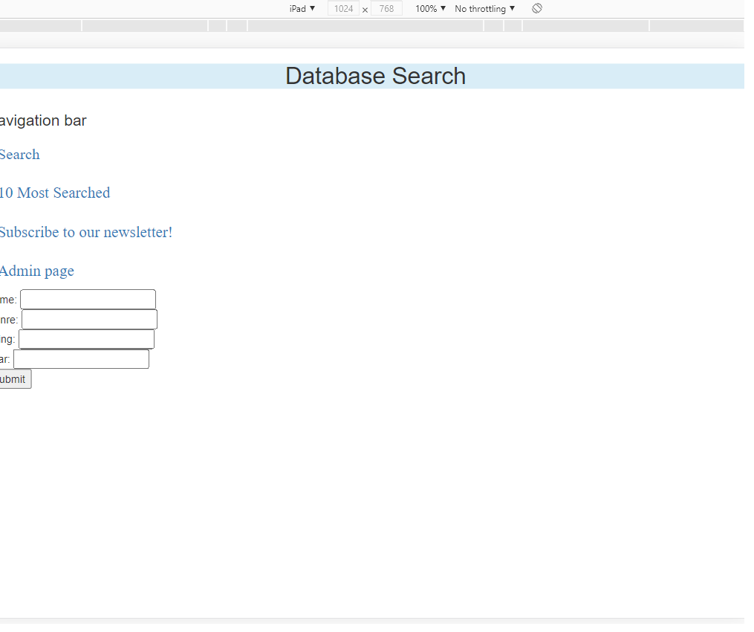

Figure 34- Runs on iPad

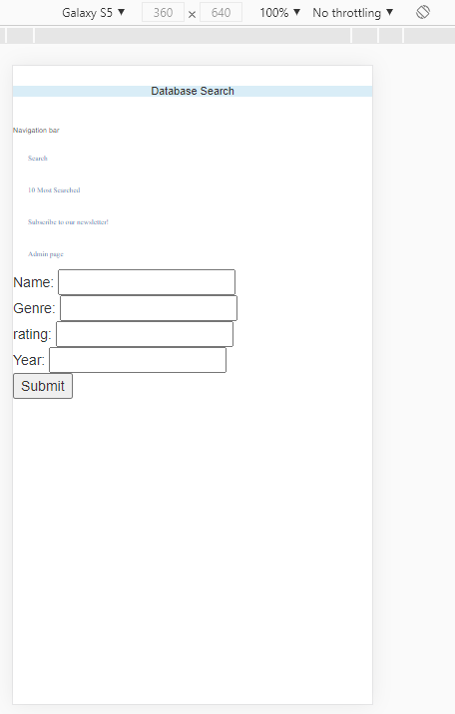

Figure 35- Runs on S5

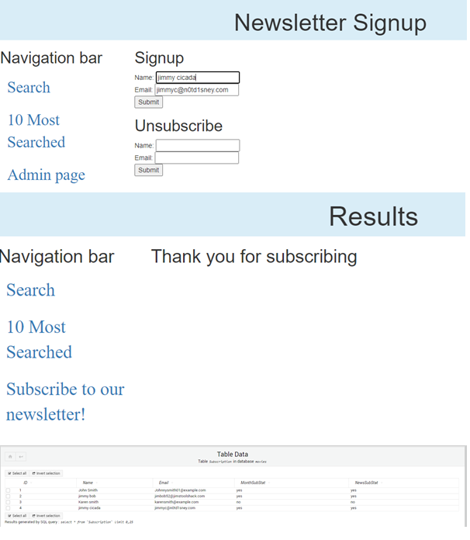

Figure 36- User unsubscribes, database not yet reflected

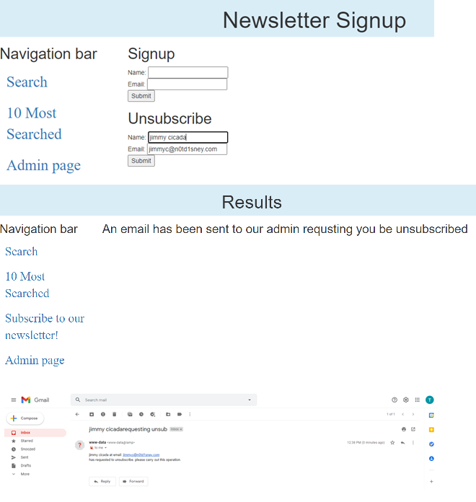

Figure 37- User unsubscribes, admin email

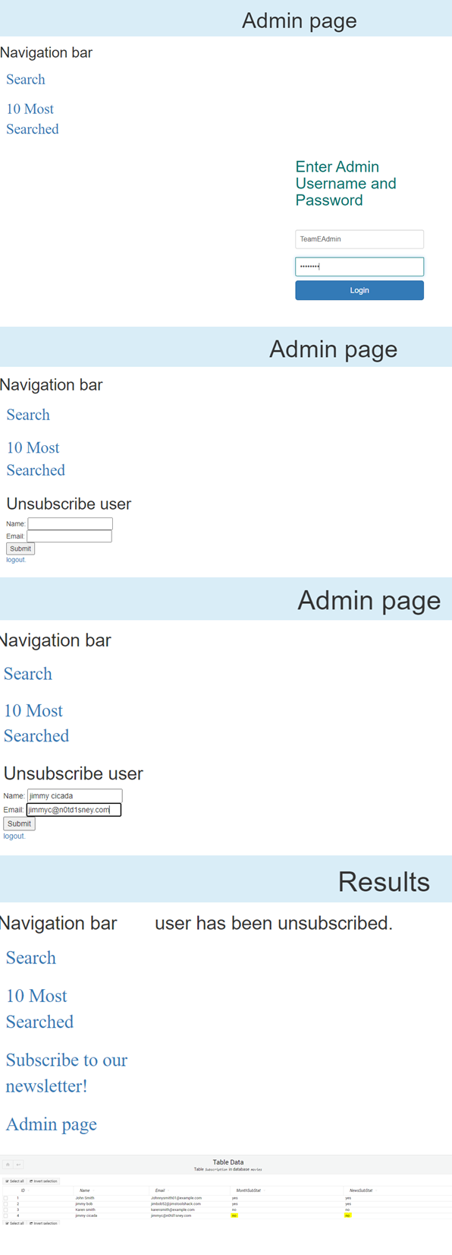

Figure 38- Admin unsubscribes user

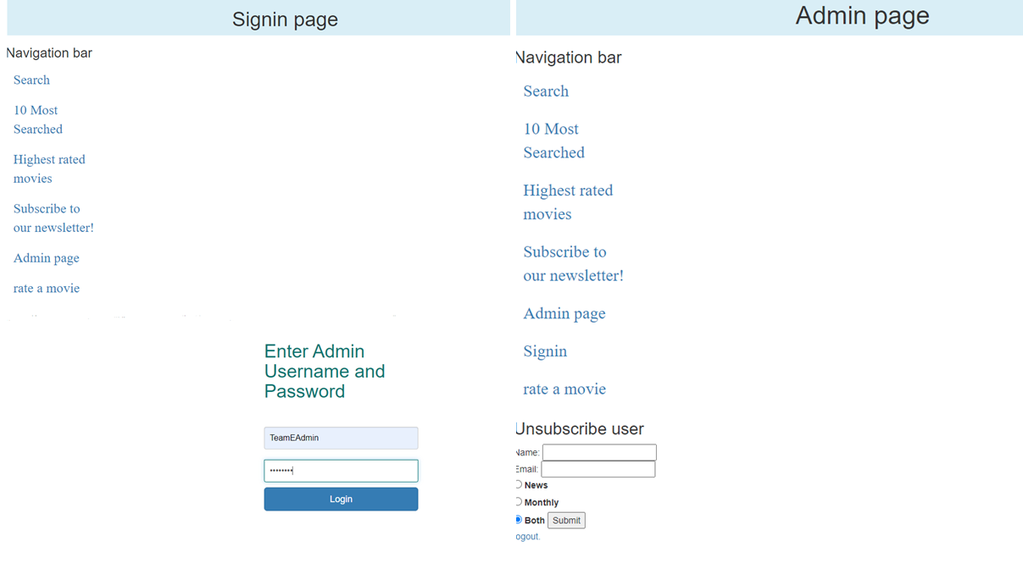

Figure 39- Admin logs in

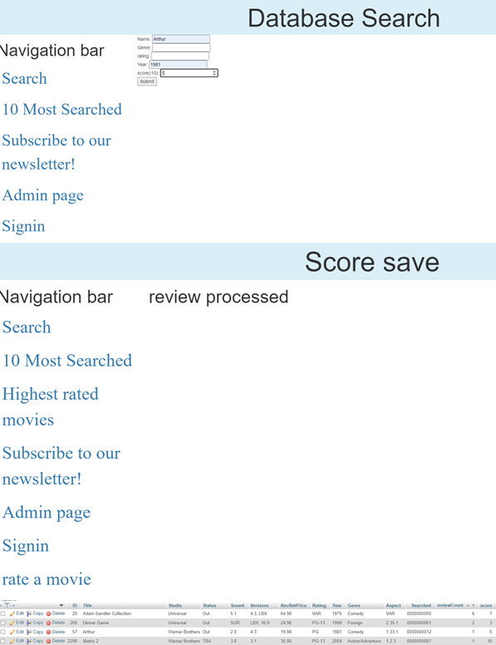

Figure 40- User leaves a score

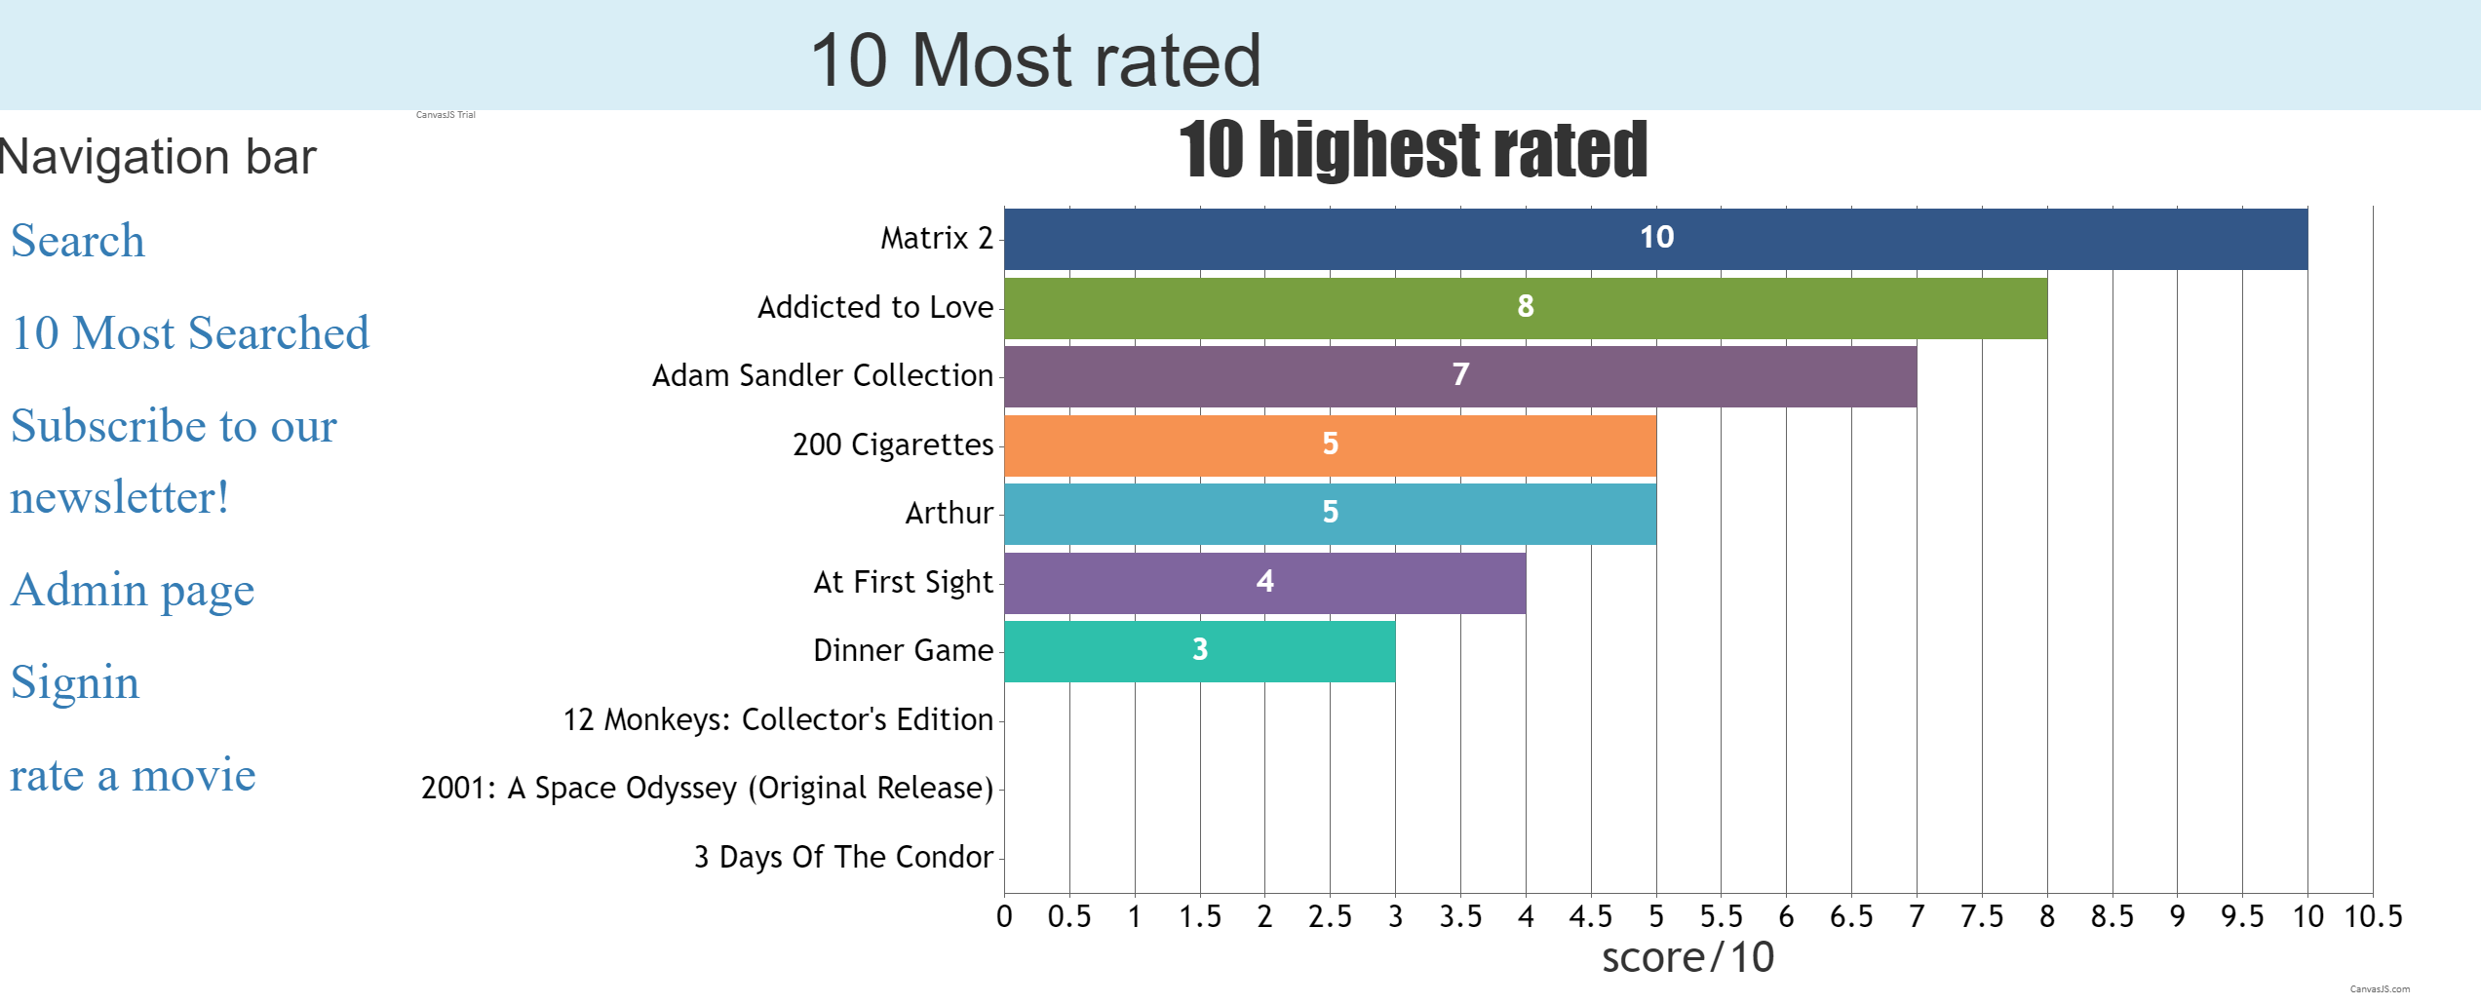

Figure 41- Ten highest-rated

### Team Meeting 3

#### Meeting Minutes

11/06/2021

Present: Blake Topham, Erol Anil, Nathan Tai

Next meeting: 17/06/2021, 9:00AM, Murdoch Campus

**Erol: Source Control Snapshot**

* Update GitHub
* Create screenshots, add to master document

**General Version Control**

* Manage repositories (GitHub)

**GANTT Chart for SPRINT THREE (week eight)**

* Timeline
* Include who does what

**Optimization report**

* List details of optimization tools to be used
* Create plan for use of tools

**BLAKE Scrum Master, Development**

* Discuss roles
* Record team meeting minutes
* Allocate tasks
* Update requirements based on client meeting
* Record minutes of client meeting

**Development tasks:**

* Admin page
* Database tables for:
  + Ratings on movies
  + User accounts
* Authentication system for accounts:
* Admin features locked behind admin accounts
* Top 10 ratings:
* Add system for rating movies out of 10
* Add a page for showing the top 10 rated movies that updates live.

**Demonstrate the Movie Database Application**

* Read and understand all documentation and code
* Demonstrate application

**NATHAN: Project Management Plan and Testing Plan**

**Software Review Plan**

* Review application against new requirements
* Update testing plan to include new features

**Master document control**

* Collate files into master document
* Proofreading
* Formatting

### Client Meeting 3

#### Meeting Minutes

10/06/2021

Present: Client, Blake Topham, Erol Anil, Nathan Tai

Next meeting: 17/06/2021, 9:30AM, Murdoch Campus

**1. Review Requirements**

* Project requirements discussed and documented.
* Project planning commenced.
* Additions requested.
  + Admin page
  + Database tables for:
    - Ratings on movies
    - User accounts
  + Authentication system for accounts:
  + Admin features locked behind admin accounts
  + Top 10 ratings:
    - Add system for rating movies out of 10
    - Add a page for showing the top 10 rated movies that updates live.
* Requirements noted and agreed.

**2. Optimization**

* Optimization report requested

### Bug Triage 3

#### Meeting Minutes

15/06/2021

Present: Blake Topham, Erol Anil, Nathan Tai

Next meeting: 17/06/2021, 9:00AM, Murdoch Campus

**1. Bug Report**

No bugs detected.

**2. Triage (Bug Priority)**

N/A

|  |  |  |  |  |  |
| --- | --- | --- | --- | --- | --- |
| **#ID** | **DESCRIPTION** | **SEVERITY** | **FREQUENCY** | **RISK** | **PRIORITY** |
| N/A | N/A | N/A | N/A | N/A | N/A |